**Ques1. Create the employees collection**

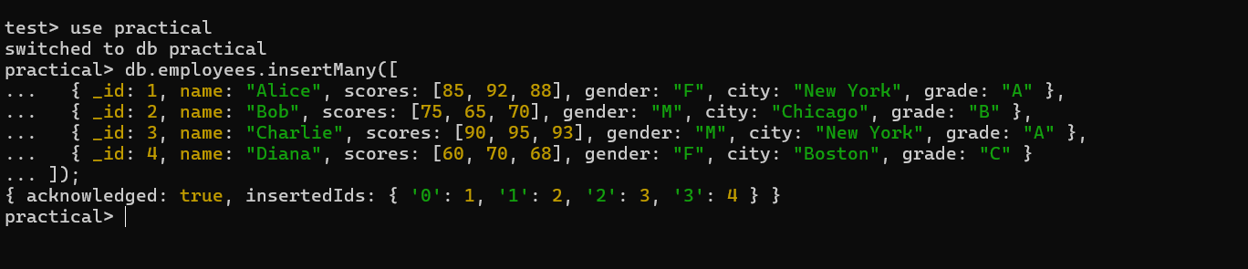

**Ques 2. Find students with any score above 90**

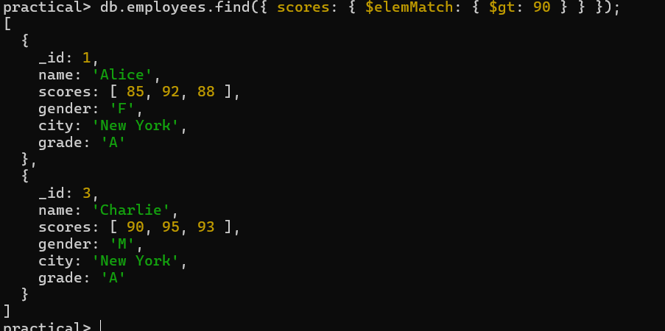

**Ques 3. Find students who have all scores 85, 92, 88**

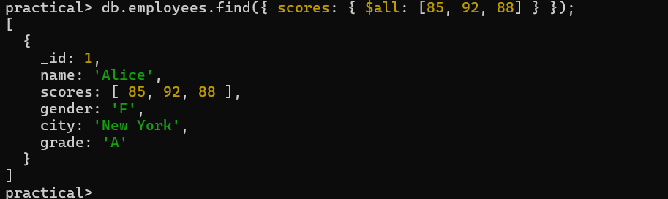

**Ques 4. Show only the first score of each student**

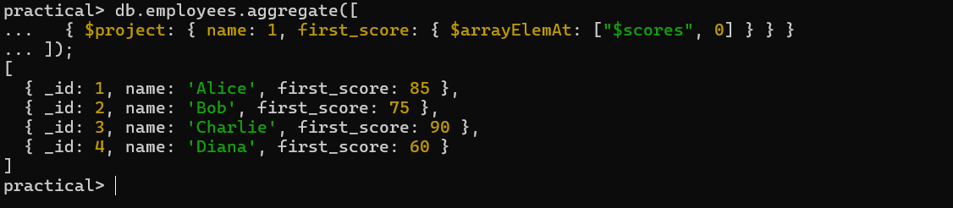

**Ques 5. Find students whose grade is not 'A'**

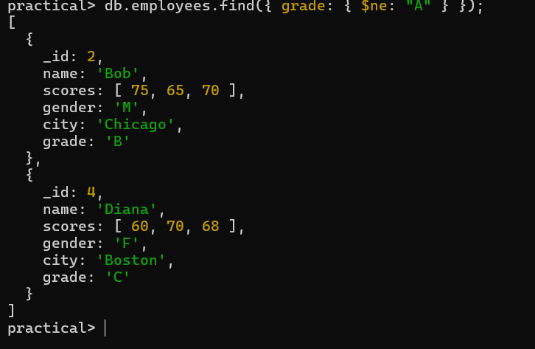

**Ques 6. Find students with average score ≥ 80**

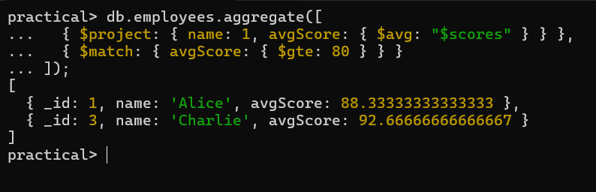

**Ques 7. Find female students from New York**

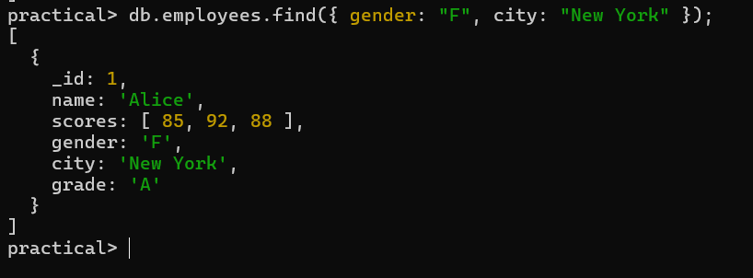

**Ques 8. Count students by city**

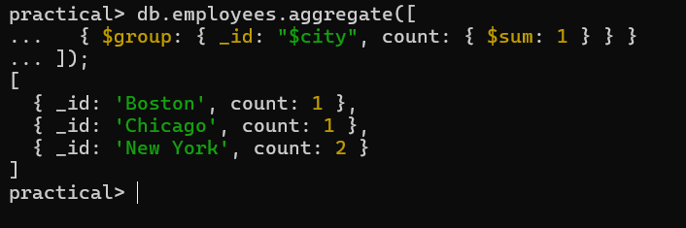

**Ques 9. Count students by grade**

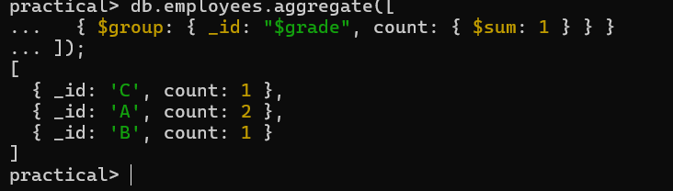

**Ques 10. Merge average scores into collection merged_scores**

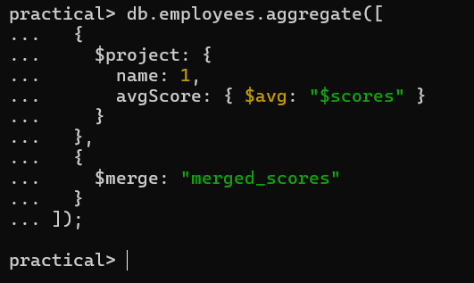

**Ques 11. Tag students as "Pass" or "Fail" (avg ≥ 70)**

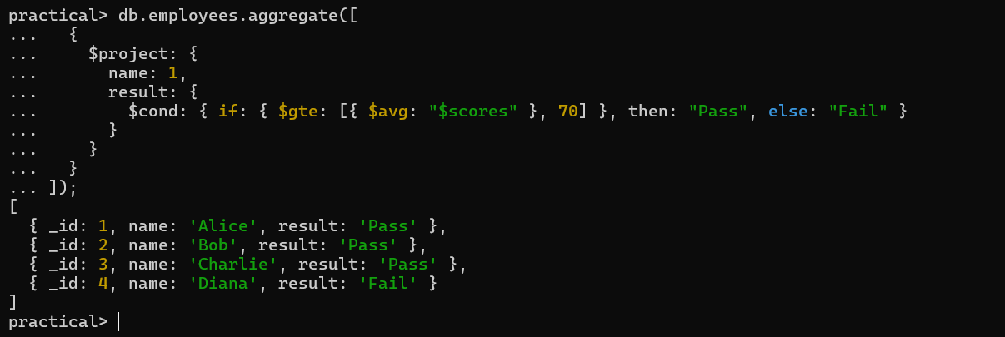

**Ques 12. Find students whose all scores are ≥ 70**

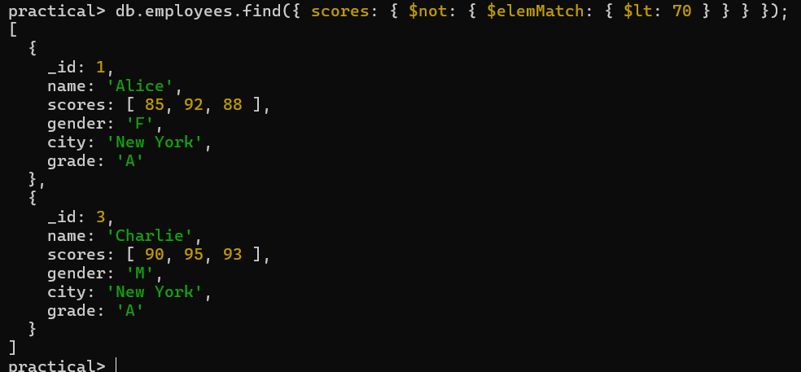 **Ques 13. Merge top scorers (avg ≥ 90) into honors collection**

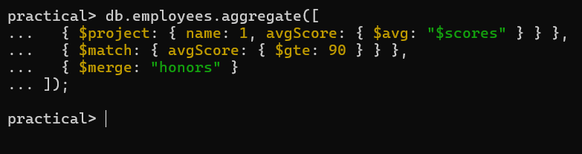

**Ques 14. Count students with grade A only, by gender**

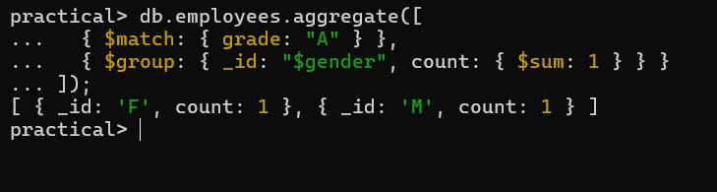

**Ques 15. Add 5 bonus points to each score**

